Tallahassee Veterinary Hospital
Drop-off Exam Form

Owner: _______________________________________ Date: _____________
Pet’s Name: _______________________ Pick-up Time: ____________
Phone Number (where you can be reached today): __________________
*Dr. Woodham will contact you after your pet’s exam.

Reason for Visit:
___ Vomiting ___ Blood in urine ___ Scratching ___ Painful ___ Ears
___ Diarrhea ___ Inappropriate urination ___ Hair loss ___ Lameness/Limping ___ Eyes
___ Blood in stool ___ Difficulty urinating ___ Coughing ___ Growth/Lump
___ Lethargic ___ Anorexia ___ Sneezing
Other: ____________________________________________________________________________________
Please give details of symptoms: __________________________________________________________________________________________
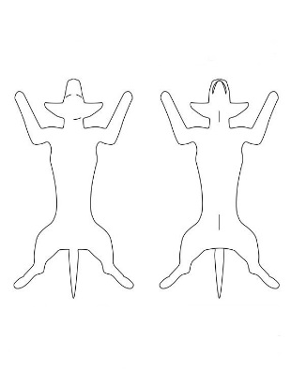
__________________________________________________________________________________________
__________________________________________________________________________________________

If your pet has any unusual lumps, bumps, wounds or skin irritation which you would like
Dr. Woodham to look at today, please note the location of each on the diagram. _________________________________________________________________________ _________________________________________________________________________ _________________________________________________________________________

Would you like to add on?
Bath ___ Shampoo Preference: Aloe & Oatmeal, Sugar Cookie, Pharmaseb, Comfort, Pearlybrite or EFA
*we will use Sugar Cookie if no shampoo is selected
Nail Trim ___ Express Anal Glands ___ Pluck Ear Hair ___ Clean Ears

__________________________________________________________________________________________
____ I authorize testing/treatment and place no limit on additional charges/services deemed necessary by Dr. Woodham.
____ Please call me with an estimate before performing any procedures not outlined in the description above. If I cannot be reached, I authorize additional treatments deemed necessary by Dr. Wodham.
____ Please call me before performing any additional procedures not outlined in the description above. I understand that if I cannot be reached, my pet will receive NO treatments, except in the case of an emergency, other than those outlined in the description above.

For the protection of our patients, all animals without the recommended vaccines will be vaccinated when admitted to TVH and done at the expense of the owner. Payment is required at the time services are rendered. We accept Visa, Mastercard, Discover, American Express, cash and check. I have read and understand the information on this form.

Signature of Owner: __________________________________________ Date: _________________________

